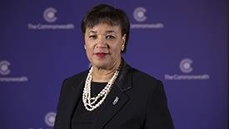
The Rt Hon Patricia Scotland QC is the sixth and current Commonwealth Secretary- General. She is the second Secretary-General from the Caribbean and the first woman to hold the post.

The Commonwealth Secretary-General is responsible for:
• Promoting and protecting the Commonwealth’s values
• Representing the Commonwealth publicly
• The management of the Commonwealth Secretariat

Since taking office on 1 April 2016, Commonwealth Secretary-General, Patricia Scotland, has been focused on helping Commonwealth countries to achieve the recently ratified United Nations Sustainable Development Goals, work towards the delivery of COP 21 and to uphold The Commonwealth Charter.

She has identified the following priorities: tackling the existential threat of climate change; promoting trade, good governance and human rights; ending violence against women and girls and promoting gender equality; and providing new opportunities for Commonwealth young people and enabling the next generation to achieve their full potential.

Secretary-General Scotland has been delivering on these priorities:

- Holding a high-level dialogue in her first week to develop a Commonwealth plan to deliver COP 21 and 22.

- Hosting the Tackling Corruption Together Conference, during which she announced the creation of the Office of Civil and Criminal Justice Reform.

- Launching the Commonwealth Hub to ensure the active network of intergovernmental, civil society, cultural and professional Commonwealth organisations are working together in a collaborative, dynamic and innovative way.

- Holding an inaugural women’s leadership summit in July to develop a Commonwealth manifesto and action plan on gender issues and equality.

- Launching a new and exciting student leadership programme with Common Purpose in July, which will capture the talent and innovation in universities across the Commonwealth and boost students’ leadership skills.

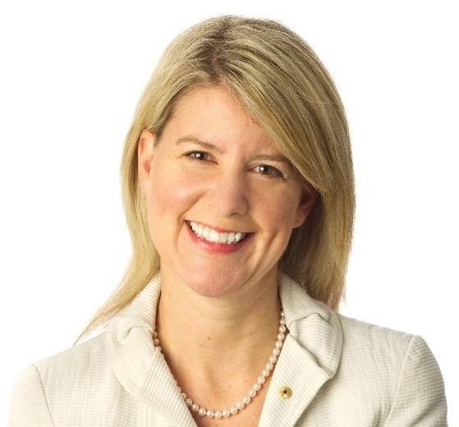Ambassador Natasha Stott-Despoja

Ms Natasha Stott Despoja AM was appointed
Australia’s Ambassador for Women and Girls on
16 December 2013. She is also the founding Chairperson of Our Watch (the Foundation to Prevent Violence Against Women and their Children). She has represented Australia at international meetings such as the UN Commission on the Status of Women, the APEC Women and the Economy Forum, the UN Security Council Open
Debate on Women Peace and Security, the Global Summit on Ending Sexual Violence in
Conflict, the G(irls) 20 Summit and the ASEAN Commission on the Promotion and Protection of the Rights of Women and Children. Ms Stott Despoja is a former Senator for South Australia (1995-2008) and former Leader of the Australian Democrats, and is both the youngest woman ever to enter the Australian Federal Parliament and the longest-serving Democrat Senator in the party’s history. Throughout her career, Ms Stott Despoja has made a contribution to a wide-range of policy debates. During her political career, she introduced Private Member’s Bills on issues including paid maternity leave, the Republic, genetic privacy and stem cells, data privacy, and audio description and captioning services. Ms Stott Despoja has an enduring interest in women's leadership, particularly political and parliamentary leadership, and has previous experience as an election monitor in countries such as Nigeria and Cambodia. In recognition of her service to the Australian Parliament, to education and as a role model for women, in 2011, Ms Stott Despoja was made a Member of the Order of Australia. She is a columnist for The Adelaide Advertiser.
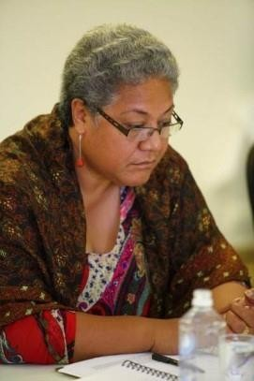Hon. Fiame Naomi Mata’afa

Hon Fiame is the current Deputy Prime Minister and Minister of Natural Resources and Environment. She has been a Cabinet Minister since 1991 and has held the Justice and Courts Administration, Censorship; Education, Youth, Sports and Culture; Labour; Women, Community and Social Development portfolios. Following the March 2016 national elections, she was selected as the country’s first woman Deputy Prime Minister, and is also the new Minister of Natural Resources and Environment. Hon Fiame is the Pro- Chancellor and Chair of the University of the South Pacific (USP) and is also the Pacific Regional
representative on the Commonwealth Women Parliamentarians (CWP) Steering
Committee of the Commonwealth Parliamentarians’ Association. Hon Fiame is an advocate of women’s development especially in the area of women in politics. She maintains strong ties with the Samoa National Council of Women (NCW) and the Inailau Women’s Leadership Network, both of which she has been a longstanding member.

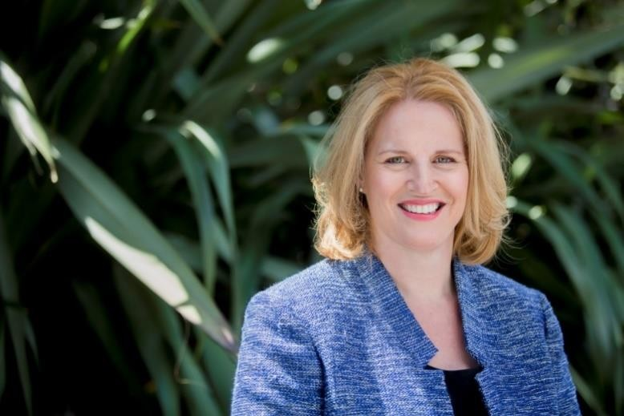Hon Louise Upston

Louise Upston is the Member of Parliament for Taupō, a seat she has held since the General Election of
2008.

In October 2014 Louise was appointed Minister for Land Information and Minister for Women; and was given responsibilities as Associate Minister
of Local Government; and Associate Minister for Tertiary Education, Skills and
Employment. She is a Member of Parliament’s Justice and Electoral Committee.

As Minister for Women, Louise is focused on utilising women’s skills and growing the economy, supporting and developing women leaders, encouraging more women and girls into education and training, and ensuring women and girls are free from violence. Within this portfolio, Louise is also responsible for the international reporting requirements relating to the status of women in New Zealand.

Prior to being appointed a Minister, Louise was Government Chief Whip for two years and was Junior Whip for one year. She has also served on the Parliamentary Service Commission and has been a member of the Government Administration, Education and Science, Local Government and Environment, and Maori Affairs select committees.

Before entering Parliament in 2008 Louise was self-employed as a project management consultant. She also held directorships in a number of trusts and companies involved in property, tourism, project management, and consulting. Louise holds an MBA from Waikato University.

Louise currently lives in Karapiro, south of Cambridge, with her three children. She enjoys participating in sporting events and has competed in the Round the Lake Relay, the Lake Taupo Cycle Challenge, and the 63.3 km challenge - three Taupo-based half marathons in three months. She is also co-captain of the Parliamentary netball team.

Fuimapaoao Naea Beth Onesemo-Tuilaepa

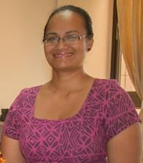Fuimapoao Beth Onesemo holds a LLB Degree from the University of Tasmania Australia, LLM from University of New South Wales Postgraduate Diploma in Business Management from University of New England. She worked for the Ministry of Justice and Courts Administration, as a consultant for the Samoa Police Service, and the Public Service Commission for 11 years inclusive of 6 years as Chief Executive Officer PSC. She is now the CEO for the Ministry of Women, Community and Social Development.
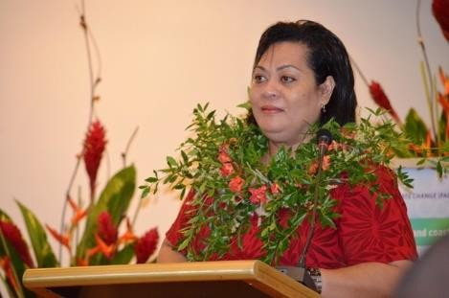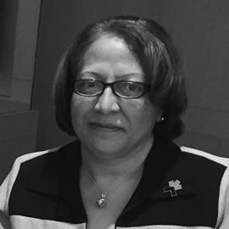Ms. Amelia Kinahoi-Siamomua

Amelia Kinahoi-Siamomua is a development practitioner/economist, with over 30 years of experience working on sustainable development, gender equality and women’s empowerment. She is currently the Head of the Gender Section of the Commonwealth Secretariat. She has had a distinguished career with the United Nations, as the Inter-Regional Adviser (SIDS-Small Island Developing States) with the United Nations Department of Economics and Social Affairs (DESA) in New
York, Senior Gender Advisor with UNDP and Regional Programme Director of the United
Nations Development Fund’s (UNIFEM) Pacific Regional Office. Amelia served in previous capacities as the Women’s Development Adviser and Head of the Pacific Women’s Bureau of the Secretariat for the Pacific Community (SPC) and also as Senior Gender Advisor, with CARE International in Atlanta, USA. As a development economist, she served with regional and other international organisations on economic and social development as the Development Cooperation Adviser for the Pacific Islands Forum Secretariat (PIFS), with the Asian Development Bank, and in her home country as an Economist for the Tonga Development Bank.

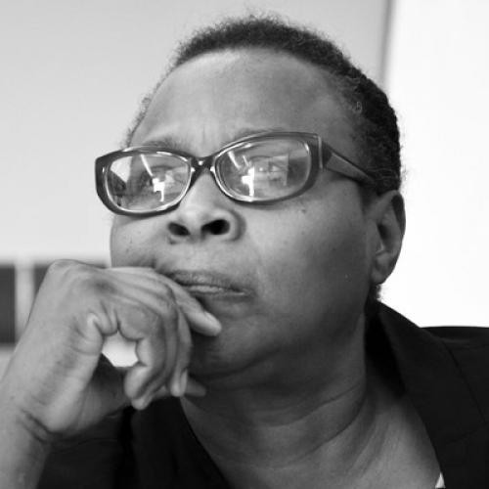Dr Mariama Williams

Mariama Williams, Ph.D. is a feminist economist with over 20 years of experience working on economic development with a focus on gender equality and women’s empowerment and social equity in international trade & finance arena as well as on climate change. Her most recent publication is Gender and Climate Financing: Coming out of the Margin (Routledge 2015). Williams is currently Senior Researcher, Global Governance for Development Programme and Senior Programme Officer of the South Centre, an
inter-governmental Think Tank of developing countries based in Geneva Switzerland. She has for the last five years followed the climate negotiations at the UNFCCC, including the negotiations of the Paris Agreement, as a member of South Centre’s team.
Dr. Netatua Pelesikoti

Netatua Pelesikoti, Ph. D is a coastal ecologist by profession. Pelesikoti has been attending the UN Climate Change Negotiations since 2010 and with her role as a Leading Author in Chapter 29 of the 5th IPCC Assessment Report. Pelesikoti is the first and only Pacific island woman to be a lead author of the 5th
Assessment Report of the Inter-Governmental Panel on Climate Change. Dr. Netatua
Pelesikoti is the Director of the Climate Change Division at the Secretariat of the Pacific Regional Environment Programme (SPREP). She is also a lead contributor to Chapter 29 on Small Islands in the 5th Assessment Report. Pelesikoti has over 20 years’ experience in climate change, coastal management and disaster risk management. She was also an advisor at the Secretariat of the Pacific Applied Geoscience Commission (SOPAC).

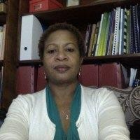Mrs. Carol Watson Williams

Carol Watson Williams, Ph. D is a social policy analyst and researcher, with special interest in applying rights based approach to social policy issues. She has worked for over two decades on a range of social policy issues, and has a special interest in how effective policies and programmes, grounded in data, can drive improvements for the lives of citizens, particularly women.
For the last ten years she has been a social policy
consultant, focusing on policy development, gender analysis, programme monitoring and evaluation, strategic planning, and policy advice and research. During this time, she has done work for organisations such as the Inter-American Development Bank (IDB), World Bank, UNICEF, UNFPA, UN Women, UN HABITAT, the ILO, the Planning Institute of Jamaica, The Ministry of Education, the Ministry of Health, Office of the Prime Minister, and the University of the West Indies, working in Jamaica and the Caribbean. As an adjunct faculty at the Institute for Gender and Development Studies, UWI, Mona Unit, she has taught an undergraduate course in Gender Analysis in Development Policies and Programmes in the Caribbean.
Dr. Nicole Hayle
Nicole Haley, Ph.D is an Associate Professor at the Australian National University (ANU), convenor of the State, Society and Governance in Melanesia (SSGM) Program and lead researcher in the program’s Politics, Elections, Leadership and Governance research cluster. She has over 25 years of research experience (including fieldwork totalling more than 6 years) in
the Pacific and remain actively engaged in deep long-term empirical and applied policy- relevant research. She has published extensively on aspects of political and social conflict, including social identity and land politics, elections and electoral politics, conflict and armed violence, and the links between these and service delivery failure. She has worked extensively with AusAID, DFAT, the World Bank’s Justice for the Poor (J4P) program and UNDP, and engaged in various advisory and consultative capacities. In recognition of her public policy achievement she was awarded the 2014 Vice- Chancellor’s Award for Public Policy and Outreach.

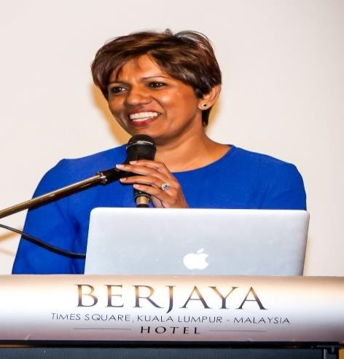Ms Anne Abraham
Anne Abraham through her corporate career has always been a strong advocate for women’s advancement in leadership positions. Having led the Malaysian operations of two of the largest global technology companies in their space, she went on to start her own organization, LeadWomen Sdn Bhd, a consulting and training organization, committed to changing perceptions and mindsets on the significance of balanced gender representation at the board and senior leadership levels of corporations. As founder and CEO of Lead Women, Anne plays a pivotal role in guiding the
company’s vision and mission towards developing and advancing women across the
corporate sectors in Malaysia. She is very engaged in initiatives supporting the Malaysian government’s aspirational goal of 30% women representation in decision- making positions and boards of Malaysian public listed companies by 2016. She is the co-founder of the Malaysian 30% Club, a part of a global business movement focused on gender balance at the top. She is a frequent speaker on this topic: Women in Leadership Forums by Naseba (2010, 2013), Asia Pacific Malaysia-China Economic Women’s Forum (2010), Corporate Governance Symposium 2013 & 2014 (Women on Boards), HR Summit
2014, Asian Institute of Chartered Bankers (2015) and is also a patron for Gorgeous
Geeks (established in 2007 to support women in technology).
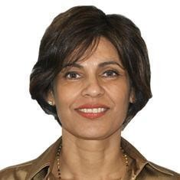Anne is a Non-Executive Independent Director in a Malaysian PLC, member of the risk and audit committees, and a member of the Malaysian Small Medium Enterprises Panel for Women Entrepreneurs.

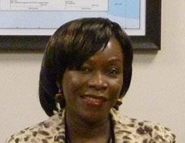Marren-Akatsa - Bucachi is currently the Executive Director of the Eastern African sub regional Support Initiative for the Advancement of Women (EASSI). She holds a Bachelors’ degree in Sociology and is completing her Masters’ in Public Health Leadership. Between
2006/2007, Marren chaired the Commonwealth Women’s Network and coordinated the team that organised the Commonwealth Partners Forum preceding the
Commonwealth Women’s Affairs Meeting held in June 2007, in Kampala, Uganda. She has over 20 years’ experience in development work. EASSI was founded in 1996 as a follow up of the 4th world Conference on Women held in Beijing, China. Its main objective is to monitor implementation of the Beijing Platforms for Action in 8 countries in Eastern Africa. She is especially passionate about violence against women (VAW) caused by misuse of small arms. She serves on the Advisory Committee of the International Action Network of Small Arms, and is also the convener of its thematic group on strengthening networks. In December 2010, she inspired a solidarity visit to the DRC as part of her interest in Africans supporting fellow Africans, and mobilised 50
women from Eastern Africa. This was a first.

P. Imrana Jalal
Senior Social Development Specialist
(Gender and Development)
Sustainable Development and Climate Change
Department
Asian Development Bank, Manila
Imrana is a Senior Gender Specialist at ADB. She is from
Fiji.
Imrana is currently a member of UN Women’s Expert
Advisory Group guiding the production of the next, 2018,
Progress of the World’s Women flagship report.
A lawyer by profession, she was formerly a Commissioner of the Fiji Human Rights Commission, and the Fiji Law Reform Commission. Imrana is the author of Law for Pacific Women and architect of the Fiji Family Law Act 2003 which addressed children's needs and removed systemic legal discrimination against women. Her book is a recommended text book at the University of the South Pacific Law School.
Imrana is a founding member of the Pacific Regional Rights Resource Team (RRRT) and was its Human Rights Advisor for over 13 years. She has also served as a barrister and solicitor in the Attorney General's Office of Fiji, as Public Legal Advisor, and has been an advisor to various UN agencies. Imrana has also been a social/political columnist in the Fijian daily newspaper, The Fiji Times,
She is a founding member of a key NGO, the Fiji Women’s Rights Movement. Imrana is also a member of the networks, Women Living Under Muslim Law, and the Asia-Pacific Forum on Women, Law and Development. Ms. Jalal was elected to the Geneva-based International Commission of Jurists as one of its 60 Commissioners in 2006, and continues to sit on its Executive Board.

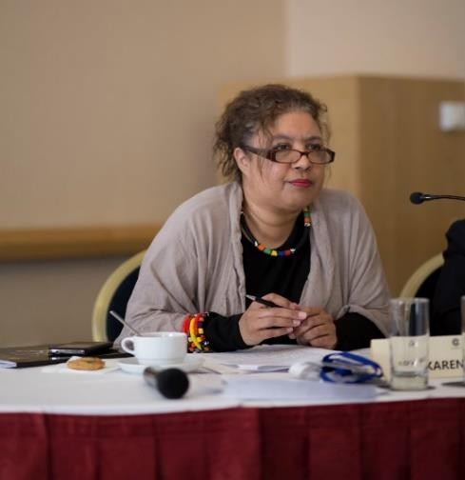Advocate Karen McKenzie

Advocate Karen McKenzie is the Head of Human Rights at the Commonwealth Secretariat. She is a lawyer by training and has practised as an Advocate of the High Court of South Africa. She is the former, and has thus far been the only woman, Police Ombudsman for South Africa.

Post-apartheid, she served in the Ministry of Justice and the Ministry of Police where she worked in several areas pertaining to reconciliation, reconstruction and
development, security sector reform, capacity development of law enforcement
agencies and the judiciary, as well as the reform and strengthening of institutions responsible for democratization.

Selected past experience: she has been a member of the Interpol Group of Experts on Corruption; an Expert Adviser to the African Commission on Human and People's Rights; a member of the drafting team for the Robben Island Guidelines on the prohibition and prevention of torture in Africa; a member of the Task Team responsible for crafting the Anti-Rape Strategy for South Africa; and established the African Policing Civilian Oversight Forum. She has worked on international programmes for UNICEF, UN Women, UNODC, UNFPA, the EU and several governments.
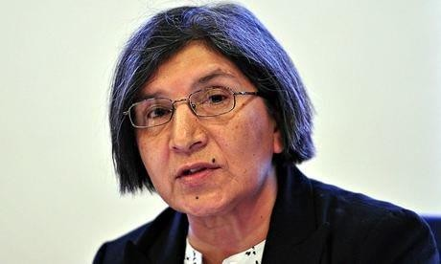Professor Rashida Manjoo

Rashida Manjoo is a Professor in the Department of Public Law, University of Cape Town, South Africa. She is the co-convenor of the Human Rights Program in the Law Faculty where she teaches, supervises and advises students. She is the former United Nations Special
Rapporteur on Violence against Women, its Causes and Consequences (2009 -2015), a post that she was appointed to by the UN Human Rights Council and Prof Manjoo has over three decades of experience in social justice and human rights work both in South Africa and abroad. Her research interests include human rights broadly with a particular focus on women’s human rights. She has authored a number of journal articles, book chapters and reports on women’s human rights, violence against women, transitional justice, and also the impact for women of the recognition of Muslim Personal Laws in South Africa. Her recent book publications include ‘Women’s Charters and Declarations
–Building another World’ and ‘Due Diligence in Addressing Violence against Women in
Sub-Saharan Africa’.

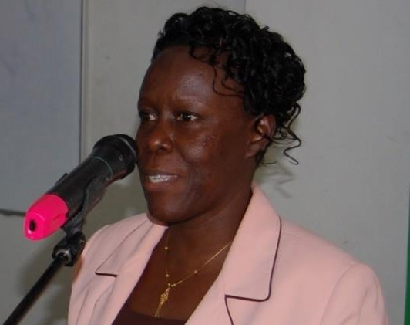Justice Lillian Tibatemwa-Ekirikubinza

Justice Lillian Tibatemwa-Ekirikubinza is the first Ugandan to be appointed as Justice of the Constitutional Court and the Supreme Court solely on scholarly work. As a Professor of Law, she served as the first female Vice-Chancellor of Makerere University from 2004 -2013. She was the first East African female to graduate with a PhD in Law and first Female Professor of Law in the region. She
enrolled as an advocate of all Courts of Uganda’s Judicature in 1988. Justice Lillian is
an experienced and widely researched legal scholar in Comparative Criminal Jurisprudence and an accomplished author of pioneer text books on the substantive law of crime based on judicial interpretation of Uganda’s principal criminal legislation (the Penal Code). She is widely published in referred law journals, text books and completed the Commonwealth Judicial Bench-book on VAW in East Africa. Although she joined the Judiciary in July 2013, since 2000 she pioneered trainers on the Jurisprudence of Equality Programme into Uganda’s judiciary, and introduced the training of Judicial Officers in the area of Gender and Human Rights. Justice Lillian holds a Ph.D. in Law (specialized in Gender and the law, Criminal Law and Criminology) from the University of Copenhagen, Denmark, an LL.M in Commercial Law from the University of Bristol, U.K, an LL. B (Hons.) from Makerere University in Uganda, and a Diploma in Legal Practice, Law Development Centre, Kampala.

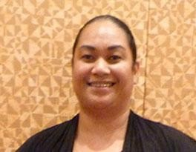Ofa-Ki-Levuka Guttenbeil-Likiliki

Director of the Women and Children Crisis Centre (WCCC) in Tonga, Ofa has a post-graduate degree in media from the University of Auckland and also has a Diploma in International Broadcast Journalism with the Thomson Foundation in collaboration with the University of Cardiff, Wales. Her passion is telling women’s stories
in the context of advocating for their rights, particularly in situations where women and girls’ rights to development and rights to accessing public services are violated. She believes that when you share the lived realities of women’s struggles and challenges, only then can you start talking about REAL solutions. She is passionate about the issues of violence against women and girls, women in decision making and women’s property and land rights and how all these issues relate to each other in the context of advocating for the overall achievement of Gender Equality and the meaningful empowerment of women and girls in Tonga and the Pacific. In 2010 the WCCC, under the leadership of Guttenbeil-Likiliki, received the prestigious South Pacific Commission (SPC) Human Rights Award in recognition of their work in promoting women’s human
rights in Tonga.

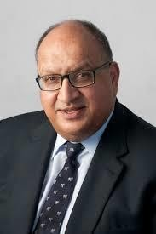Sir Anand Satyanand

The Rt Hon Sir Anand Satyanand was sworn in as New Zealand's
19th Governor-General (head of state) for a five-year term in August 2006. He was New Zealand's first Governor-General of Indian and Pacific ancestry and has had a lengthy career as a lawyer, judge and ombudsman as well as contributing to many community, professional and sporting groups. In international affairs, he has served on the governance boards of the Asia New Zealand Foundation and the New Zealand Institute of International Affairs, and Transparency International.

In 2013, the then serving Commonwealth Secretary-General Kamalesh Sharma announced Sir Anand Satyanand as Chair of the Commonwealth Foundation for an initial two-year term.

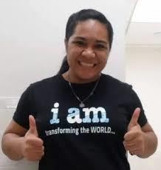Ms Tahere Talaina Siisiialafia

Tahere T Siisiialafia of Samoa is a graduate in Sociology and Psychology with post graduate in Social Work and currently, a Sociology Lecturer at the National University of Samoa. She has been involved in community development especially with children all through her life through faith-based activities and as a caseworker and coordinator for a youth-led social work NGO called Really Make A Difference (served socially deprived young people in squatter settlements) for two and a half years in Fiji. In 2013 she was elected as an
Executive Board Member on the Pacific Youth Council (PYC) which is a regional youth-
led NGO platform for the interests, needs and development of young people in the Pacific region. She has been representing Pacific young people at national, regional and international events and especially in the various Post-2015 agenda processes with the key aim to promote a global understanding of issues affecting young people in SIDS and at the same time foster cooperation and collaboration with all relevant youth development partners to promote engagement with young people. Her most recent participation and engagements involves representing the Pacific Youth Council on the UN Major Group of Women and the UN Major Group for Children and Youth, the Commonwealth Foundation, Young Feminist’s Fund, and the Commonwealth Youth and Sports for Development and Peace and other various Commonwealth Youth Networks.

Dr Balasubramanian Kodhandaraman

Dr Kothandaran is a professor in the Department of Ruber and Plastics Technology at Anna University in India. Her research interests are on toughened epoxies and nanocomposites based on epoxies and rubbers She holds a Ph. D in Composites (1999) as well as a Masters’ in Rubber Technology (1987) and Chemistry (1985) and a Post- Doctoral Research from Politecnico di Torino (2010-11) on Nanocomposites. She has published 9 papers in several journals and has presented numerous papers.

