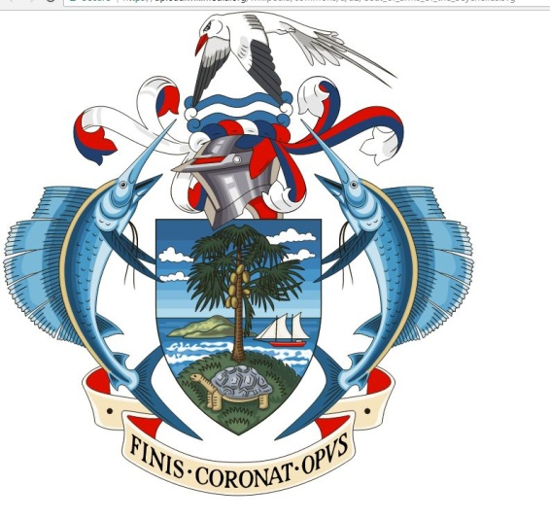
THE CONSTITUTIONAL APPOINTMENTS AUTHORITY
APPOINTMENT OF PRESIDENT OF COURT OF APPEAL
A vacancy exists for a post of President of the Court of Appeal of Seychelles.
Applications are invited from persons who are qualified under Article 122 of the Constitution of Seychelles.
The person must be suitably qualified in law, effectively, competently and impartially discharge the functions of the office of the President of the Court of Appeal under the Constitution of the Republic of Seychelles.
The appointee should preferably hold or have held high judicial office in Seychelles or elsewhere in the Commonwealth and possess leadership and management experience to effectively manage the Court of Appeal.
The attention of applicants is drawn to the “Constitutional Appointments Authority Rules on the Selection and Appointment of Judicial Officers” (Provisional Rules) in particular Rule 7 and the First Schedule which can be viewed on the Authority’s website www.caaseychelles.com
The Court of Appeal has jurisdiction to hear and determine appeals from a judgement, direction, decision, declaration, decree, writ or order of the Supreme Court and such other appellate jurisdiction as may be conferred upon by the Constitution and by or under an Act.
The salary, pension, gratuity, allowances and benefits attached to the post are set out in Section 9(1) of the Judiciary Act No. 9 of 2008.
Applications including CVs, legal qualifications and two references should reach the office of the Chairperson, the Constitutional Appointments Authority, La Ciotat Building, Mont Fleuri, on or before 31st October 2019.
Address of Office: La Ciota Building, First Floor, Mont Fleuri
Telephone :+248 4322504
FAX: + 248 4323112
E:mail : caa.seychelles@gmail.com
Website: www.caaseychelles.com

