COMMONWEALTH SECRETARIAT
MARLBOROUGH HOUSE, PALL MALL, LONDON SW1Y 5HX

Invitation to Tender

For the provision of Audio Visual Equipment to the Commonwealth Secretariat

April 2019

Reference Number: | 462-2019
Return Date: | Return Date – Noon on 23 April 2019
Estimated Contract Award: | June 2019
Contact Email: | procurement@commonwealth.int

Contents

Section | Action | Page(s)
- Introduction | For information | 3
- Purpose | For information | 3
- Tender Timetable | For information | 3
- Specification of requirements (SoR) | For information | 4 -13
Annex 1 to the SoR  – 2018 Sample Meetings and Events List & AV Equipment requirements | For information | 14-15
- Instructions for Bidders | For information | 16
- Evaluation Process | For information | 17-19
- Contract Management | For information | 19-20
Tender Submission Documents  Part 1 – Bidder Details  Part 2 – Selection Questionnaire (with Ethics Form attached)  Part 3 – Invitation to Tender - Technical Questionnaire  Part 4 – Invitation to Tender – Commercial Questionnaire/ 2A Pricing Workbook (under separate cover) | For completion and submission as part of the Tender response | 21-31
Appendix 1  Framework Agreement Standard Terms and Conditions | For review and acceptance | 32
Annex 1 to Appendix 1 Legal Comments table | For completion and submission as part of the Tender response | 33
Appendix 2- Code of Ethics | For completion and submission as part of the Tender response | 34
Appendix 3 – Parent / Group Company Statement | For completion and submission as part of the Tender response | 35
Appendix 4 – Non-Disclosure Agreement | For completion and submission as part of the Tender response | 36-38

Introduction

  - The Commonwealth Secretariat (The Secretariat) is an international organisation established by Agreed Memorandum, which is given privileges and immunities under the domestic law of the United Kingdom by the Commonwealth Secretariat Act 1966 (as amended by the International Organisations Act 2005). Under this legislation, the Secretariat is not subject to UK jurisdiction and enforcement.

  - This status has an impact on some of our standard terms and conditions. In particular, we draw your attention to our dispute resolution clause, which refers disputes to the exclusive jurisdiction of the Commonwealth Secretariat Arbitration Tribunal (CSAT). The 8 members of the Tribunal are selected by the Board of Governors and come from Commonwealth member countries. Information about CSAT, including its governing statute and procedure are available on its website at http://thecommonwealth.org/tribunal.

  - The Secretariat implements decisions agreed by Heads of Government and Ministers through advocacy, consensus–building, information sharing, analysis, technical assistance, capacity-building, and advice on policy development.

Purpose

2.1 The Secretariat wishes to establish a Single Supplier Framework Agreement for the provision of Audio Visual Equipment to the Secretariat, which will be effective for five years with an option to extend for a maximum of up to two further years.

2.2 See specification in Section 4 for details of the goods and services required.

Tender Timetable

3.1 Please note the following timeline may be subject to change if required.

Activity | Date
Invitation to tender published | 1st April 2019
Deadline for questions for be asked about the requirement by | Noon 10th April
The Secretariat publishes responses to questions asked by | 5PM on 12th April
Tender submission closing date | Noon on 23rd April
Tender Evaluation process duration | 23rd April – 3rd May
Best and Final Offers (BAFO) Stage | 7th May – 17th May
Notification of intention to Award by | w/c 20th May 2019
Framework Agreement Awarded by | June 2019
NOTE: The above timetable is indicative at the time of going out to tender. This timetable may be subject to change at short notice.

Specification of Requirements

A. Introduction to the Commonwealth Secretariat

The Commonwealth Secretariat (The Secretariat) is an international organisation of The Commonwealth serving the individual and collective needs of 53 member countries.
The Secretariat wishes to establish a Single Supplier Framework Agreement for the provision of Audio Visual (AV) Equipment and associated services.
The Secretariat implements decisions agreed by Heads of Government and Ministers through advocacy, consensus-building, information sharing, analysis, technical assistance, capacity-building, and advice on policy development.
The Secretariat’s Headquarters are based in two buildings on Pall Mall. Marlborough House is a Grade I listed Royal Palace with a gross area of 103,000 sq.ft.
B. Introduction to the Requirement
Please note: The specifications have been constructed with the Secretariat’s Consultant - The Production Exchange. We do expect the appointed supplier to advise and recommend changes to this specification as part of the project initiation.

The Secretariat is now seeking to procure the services of suitable organisations to supply, install, operate and de-rig an AV solution for the Commonwealth Secretariat. The Secretariat requires a solution which provides AV to several areas, varying in size, capacity and requirement. The Secretariat holds various meetings for which AV equipment and associated services are required. A list of meetings held in 2018 is provided for information only in appendix 1 to this specification. This list is not an exhaustive list and serves only as an example of the type of meetings that may require AV equipment/support.
The AV supplier must develop a detailed project delivery plan. This may include build, delivery and operational schedules; the review of all health and safety documents, ensuring adherence to the venue restrictions and event delivery plans.

The submitted response pricing must be inclusive of the supply, installation, operation and maintenance, derig, labour, project management and all onsite requirement costs.
A rate card for any optional features that may be required, should be detailed and full consideration given to the best way your solution will be integrated within the overall Marlborough House design. AV Technicians will be required in Marlborough House to run events. There may also be an option to have an in-house AV technician. Bidders should bid for these options by submitting their rate cards.
C. General Restrictions

Marlborough House is a Grade 1 listed building; any alterations to the fabric of the building to add additional cables to support an AV system are not considered viable. A number of existing cable routes do exist at low level between the G12 floor boxes and the G12 heating units on the outer edge of the room. These might provide potential cable routes however for the purpose of this document, we have assumed that no additional cabling or power will be installed in or between any of the rooms.

There is some limited cabling and power currently installed within the rooms, this includes a number of data points which route back to the main distribution position. The extent of this cabling has yet to be confirmed but it is likely that these can be used to distribute audio and video content between rooms, particularly between the Main Conference Room (G12) and the Delegates Lounge (G13).
As cabling routes are limited, the majority of cabling will be installed on the floor within suitable low profile surface mounted containment.

Limitations on cable routes means that any AV equipment will have to be installed within the rooms as there is no way to run multiple cables outside the room to a central AV rack.
AV racks in the rooms would be installed at locations on the edge that have minimal impact on day to day use, allowing them to remain within the room when not in use. This will greatly assist with setting up and reducing the complexity of the cabling. This in turn will result in a more reliable system. It is suggested that the AV rack is incorporated into a technician operator position and finished in a style that would blend in with the room surroundings.

A number of wireless AV systems are proposed; it will be necessary to perform an audit of the frequencies within the rooms to avoid any potential frequency clashes.
The main display screens in the room would be reused, this includes the trolley mounts.

D. Functional Requirement
This specification is intended to detail the AV functionality for the proposed update and expansion of the AV systems currently installed at Marlborough House. The document is not intended to be highly technical but to give an understanding of the functionality that will be available in the AV equipped spaces.

AV Equipped Rooms
The Main Conference Room (MCR) (G12) is the main space used for Commonwealth meetings at Marlborough House. This room will be used by up to 58 delegates (including a chairperson, Secretariat staff and speakers) seated at the main table along with a number of support staff seated in rows behind.
The adjacent room, Delegates Lounge (DL) (G13) will be used as a standalone room in theatre or boardroom layouts or as an overflow room for G12.
The Blenheim Saloon will be used for informal gatherings using a portable PA system. This room will act in a standalone capacity and will require a PA system as specified in the Bill of Materials/Blenheim tab.

Meeting Requirements
Main Conference Room - G12 Meeting Room
Boardroom
This is the standard room layout with content displayed at a pair of trolley mounted screens located at the ends of the table. Screen content is routed from either a laptop (wired or wireless) on the table or a resident PC located at the technician position. In this layout, audio reinforcement would be provided by the wireless delegate system located at each delegate position on the table top. For those not seated at the table an additional PA system would provide voice reinforcement. Loudspeakers would be discreetly mounted on the outer edges of the room.

Video conferencing would be supported using a Skype client (or BlueJeans) installed on a resident PC. Audio for video conferencing would be picked up from the delegate system with a PTZ camera mounted above the screen providing picture content.

Theatre
In theatre layout the presentations will be run from a lectern position at the front of the room. Presentation content would be routed from a laptop (lectern or at the technician position) or a resident PC at the technician’s position. In this mode, wireless lapel, lectern
or table top microphones would be used for audio reinforcement.
For Q&A sessions, handheld wireless microphones would be provided.
Video conferencing would be supported in this layout but in a presentation format with audio and video focused on the lectern position. The camera would be located on a tripod in front of the presenter.

Equipment Location
The majority of the AV equipment will be located within the room as it is not possible to remote any equipment due to cabling limitations. A piece of furniture that doubles as an operator position and AV rack would be ideal. This should be finished in a manner that blends in with the room furnishings, negating the need to remove the rack and any AV connections unless the room needs to be completely cleared.
There will be some items that need to be stored remotely including spare batteries for the wireless delegate system and the storage case for the units when not in use.

Delegates Lounge - G13 Meeting Room
Boardroom
This is the standard room layout with content displayed at the end of the table using trolley mounted screens. Additional 55inch screens are available in-house.
In this layout, audio reinforcement would be provided by the wireless delegate system located at each delegate position on the table top.
Video conferencing would be supported in this layout.

Theatre
In a theatre layout, presentations would be conducted from a lectern or top table located at the front of the room. A wireless lectern microphone would be provided along with a laptop connection if required.
For Q&A sessions a handheld wireless microphone would be provided.
Video conferencing would be supported in this layout.

Overflow
When required G13 would be configured as an overflow for G12. Audio and video content would be transmitted from the AV system in G12. The additional 55inch screens available in-house can be used in G13 allowing for the larger screens to remain in G12.

Room layout images

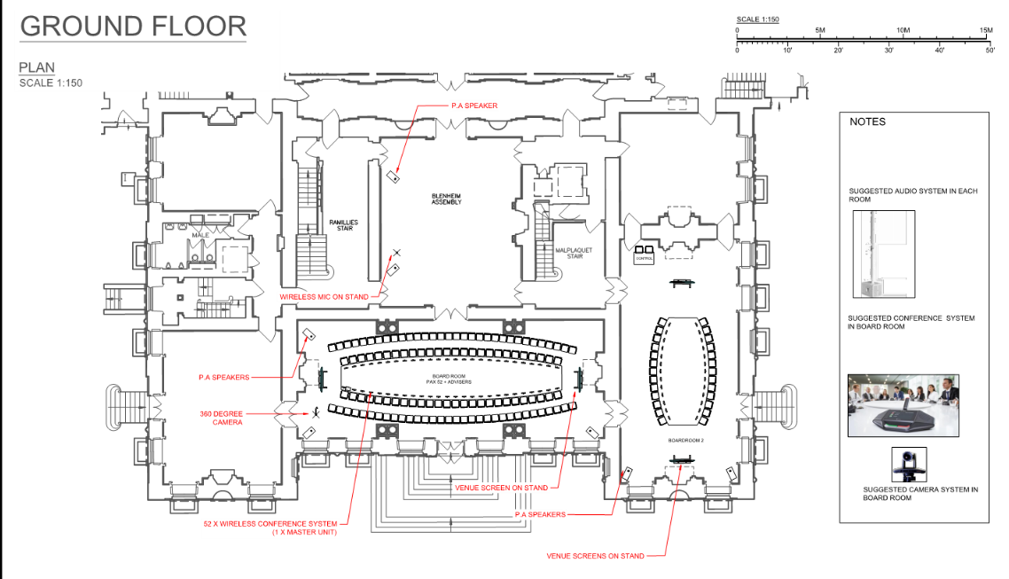
Boardroom layouts

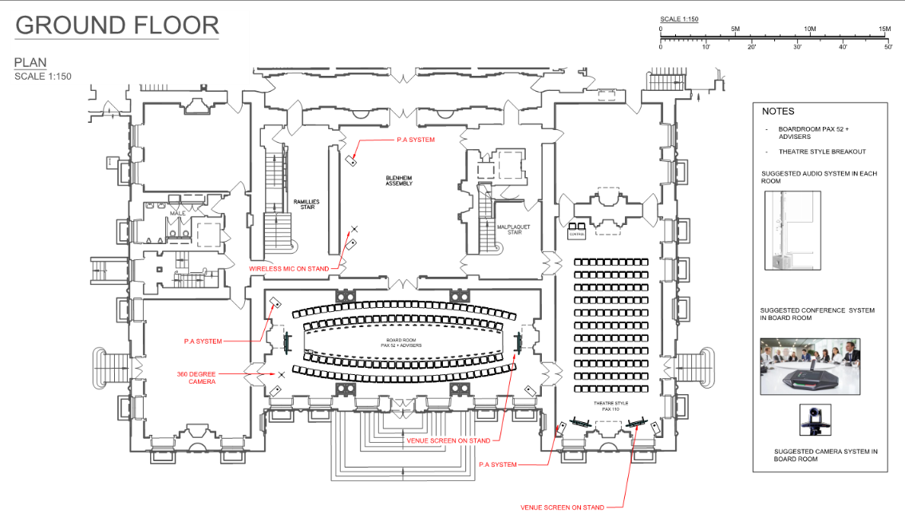
G12 boardroom layout - G13 theatre layout

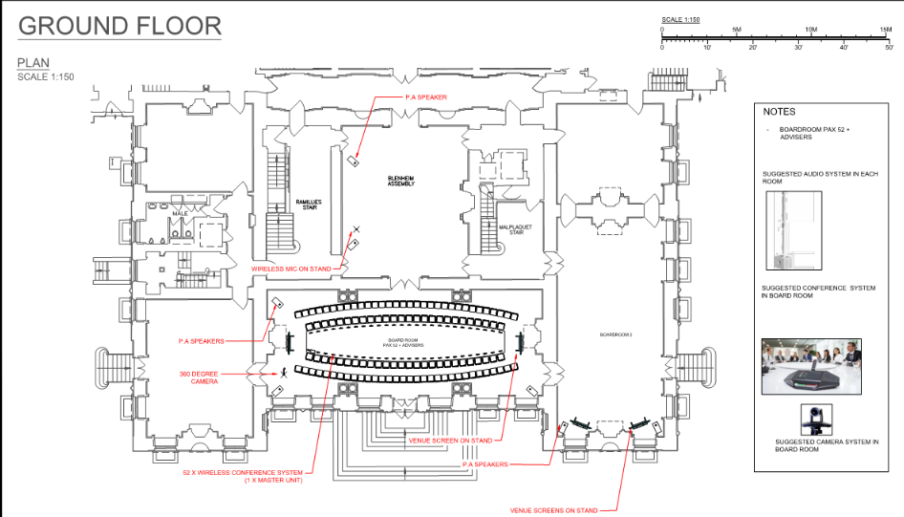
G12 boardroom layout - G13 open

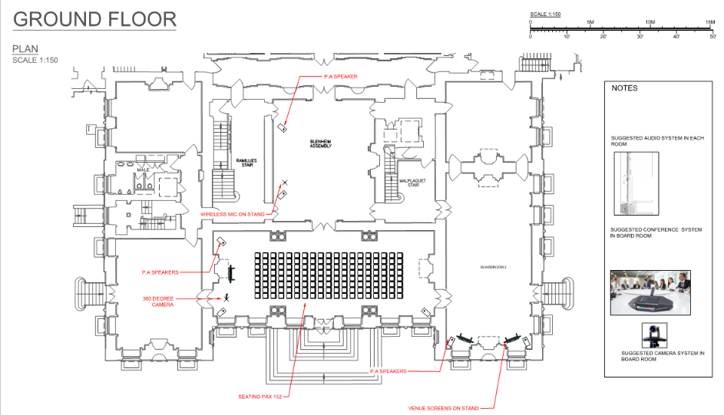
G12 theatre layout- G13 open

Equipment Details
Displays
A pair of 84inch LCD screens are currently installed in the MCR one at each end of the main table, these are trolley mounted and will be reused. There is space on the screens to mount peripheral interfaces and also a dedicated shelf for the PTZ camera used for VC calls. When G12 and G13 are combined, the screens in G13 (available in-house) would need to mirror those in G12.

Resident PC
A local PC provided as an alternative presentation device. The machine should be the same one that supports the UC video communications software. This will enable content to sharing from the PC as part of the VC call. To assist presentation from the table top or lectern the following peripherals should be included.
The eresident PC will be provided by the IT team at Marlborough House.
- Wireless keyboard and mouse
- Wireless presentation clicker
In G13 a resident PC can also be provided although this would have video conferencing installed.

Laptop (to be provided by supplier)
Wired
A hard wired laptop connection will be presented at low level in a connection box to protect the device from damage. The cabling would run down the centre of the table at low level. This cable can be up to 90M but a cable run limited to the centre of the table will probably be adequate. Robust Neutrik RJ45 connections will be used, as these items are frequently unplugged.
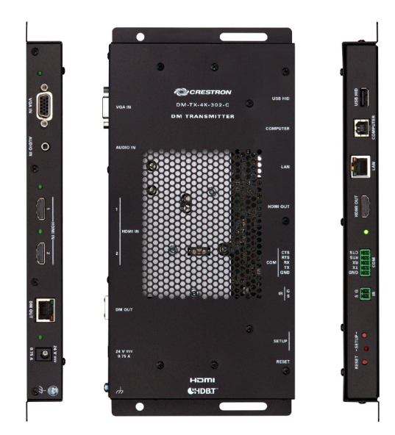
- PC transmitter unit to be located at the table.
- Flying leads required from interface to table top.
- 2No. HDMI inputs to allow alternate connection.

Wireless
A wireless presentation device will be located at the AV rack; this will enable wireless presentation from any position within the room from any device. There are a number of options but ideally, the system should support multiple platforms without the need for any additional hardware connections to the laptop. Any software required to enable presentation needs to be downloadable without the need for the user to require Admin rights to the device being used.
- Wireless presentation device
- Content wirelessly transmitted to the screen without any additional hardware
- Supports a number of different devices including PC, Mac, iOS and Android.

Wireless Delegate System
A number of manufacturers supply wireless delegate systems with varying degrees of functionality and the following are some examples.
The Televic G3 system offers a number of hardware options, which offer varying degrees of functionality. Units cannot be upgraded to add additional functionality at a later date.
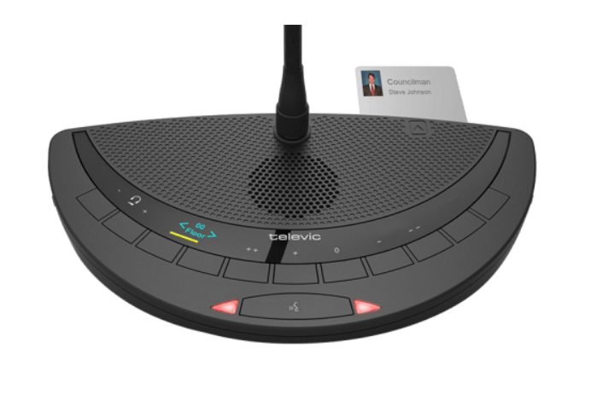
- Voting available as an option
- RFID card reader to transfer delegate information
- Up to 4 interpretation channels as an option
- Dedicated wireless access point
- Dedicated control software loaded on local PC (shows voting results)
- Built in loudspeaker and headphone jack

The Shure wireless delegate system offers a single hardware option but the software can be expanded to add additional functionality as required. The unit also benefits from a small display screen which gives details on who is speaking.

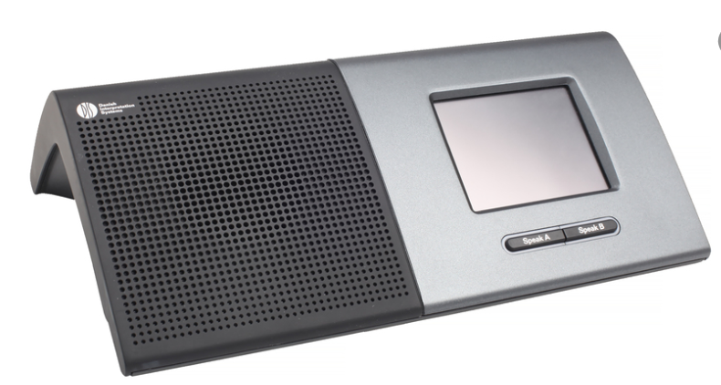

- Single unit supports all functionality
- Voting available as an option
- RFID card reader to transfer delegate information
- Up to 2 interpretation channels as an option
- Dedicated wireless access point
- Dedicated control software loaded on local PC (shows voting results)
- Built in loudspeaker and headphone jack

If required both systems also offer electronic name plates which detail the name and whether the speaker is active.

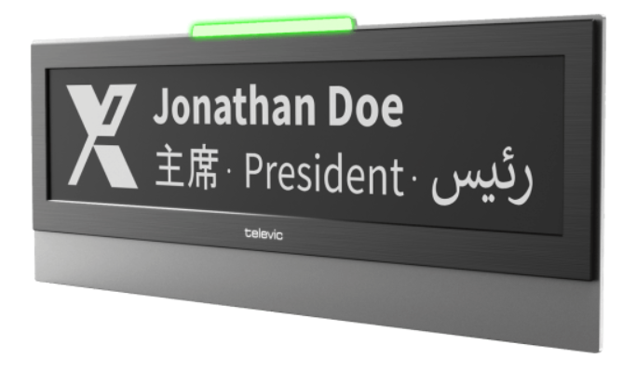

Voice Reinforcement
Main Conference Room G12
Primary audio reinforcement for speech would be broadcast through a wireless delegate system with delegates using headphones if desired. To augment this and provide coverage for those not sitting at the table an additional set of loudspeakers would be provided. It is proposed that these are mounted between the marble pillars on custom stands designed to drop in to existing slots in column base. A minimum of four positions being used.
NOTE: No permanent fixings are allowed.

Loudspeaker mounting location

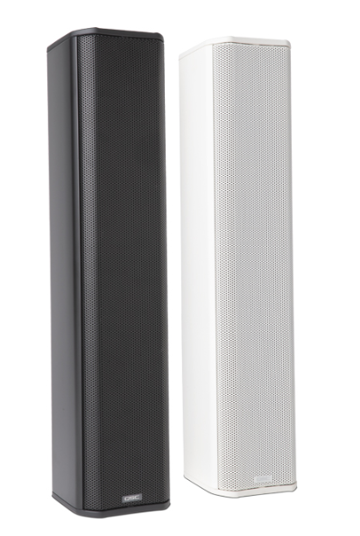
Column loudspeakers

In addition to the loudspeakers mounted at the marble pillars, loudspeakers would also be mounted on the sides of the trolley-mounted screens. These would primarily be used for presentation audio (laptops, local PC etc.).
Audio from Skype video calls would be routed though the wireless delegate system and the column-mounted loudspeakers locate by the marble pillars.

Delegates Lounge G13
A similar column loudspeaker would be used in G13, as in G12 the screen audio would be augmented with side-mounted loudspeakers.

Video Conferencing
Video conferencing would be supported using a Skype software client (or BlueJeans) on a local PC with the PTZ camera located on top of one of the LCD screens. Audio would be fed from the delegate system or the wireless microphone system. The PC should also be used for content presentation, as this will allow content viewed by all participants on the conference call.
The PC would be located at the technician position.

Wireless Content Mirroring
In addition to wireless presentation of content, it would also be possible to repeat the content displayed at the main screen back to delegate laptops/devices as long as they are connected to the appropriate wireless network. This would be particularly useful given the limited size and locations available for the large trolley mounted screens.

Wireless Microphones
When G12 or G13 are used in a theatre layout wireless microphones will be required. This will be a mixture of lapel, hand held, lectern and table top. It is recommended that all wireless communications be encrypted (as a minimum 128bit encryption is required).

- Hand held for Q&A
- Lapel for presenters who move around
- Lectern fixed wireless microphone for use at the lectern position

Space at the technician’s position should be provided for battery charging and spare microphone batteries.
Advice would be needed on the number of microphones required.

Audio only Playback
Audio only playback is required for background music content. This should consist of both a hard-wired connection and a Bluetooth wireless connection for maximum flexibility:
- Hard wired audio connection at technician’s desk
- Bluetooth connection within the AV rack at the technician’s desk for playback from suitable equipped devices such as mobile phones.

Audio Recording
Audio recording is required and can be implemented through software on the resident PC or a dedicated device. Further discussion will be required to ascertain the preferred method.

Lectern
There are existing lecterns that can be re-used, these will need an additional wireless microphone connection or alternatively could use a wired microphone however any cabling would need to run along the floor in suitable containment.

Induction Loop
It will not be possible to retrofit a conventional induction loop system in either G12 or G13 as this would need to be installed below the finished floor. The wireless delegate system will support a neck loop fed directly from the headphone output, but for other delegates in either G12 or G13 an infrared system would need to be included. This requires the user to wear a neck loop.
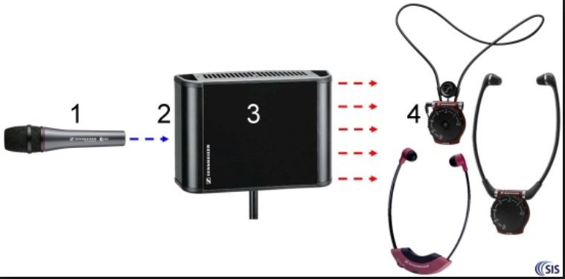

AV Control System
Control processor
A dedicated control processor will be installed in both rooms, when rooms are combined the control system in G12 will be the master, however the control system in G13 will retain control of some functions such as local volume and mute. These may need to be used independently.

Wireless Touch Panel Controller
In both G12 and G13 a wireless touch panel controller would be located at the technician’s position/AV rack. In normal use this would be connected to a docking station for charging. If required, it could be removed from the docking station and used around the room. The touch panel controller would provide the following control functions:
- System Power On/Off
- Screen source Selection and control
- Volume Control and mute
- PA mute
- Control of both G12 and G13 when used in a combined mode
- PTZ camera control
The touch panel controller will have a custom graphical user interface (GUI) which should be intuitive and require little or no training to use.

PTZ Cameras
A dedicated camera will be provided for video conferencing in G12, this will be permanently installed on one of the large mobile screens. For theatre style presentations in G12 a tripod mounted camera will be provided. Both cameras will be controllable from the technician’s position using the AV control panel.

Dilapidations
Due care and attention must be taken in order to ensure that damage is not caused to the venue, furniture etc. The appointed supplier will be liable for all such damage and will be charged accordingly.
No fixings can be made to any part of the premises. Any damage to panels, walls, columns, flooring, shell scheme stands, hire accessories etc. within the venue will be repaired at your expense. All materials must be cleared during de-rig. Charges will be levied for the removal of any abandoned articles.

Annex 1 to the Specification of Requirements

– 2018 Sample Meetings and Events List & AV Equipment requirements

2018
Meetings/Events:
- 11 December, G12, table mics & recording, full setup (56-58 at the table)
- 10 December G12, table mics, full setup (56-58 at the table)
- 7 December, G12, table mics & recording, full setup (50 at the table)
- 6 December, G12, table mics, full setup (56-58 at the table)
- 4 December, G12, table mics & camera feed to screens in the room, full setup (50 at the table)
- 29-30 November, G12, table mics & recording, full setup (56-58 at the table)
- 29 November, G13, lectern mic & lapel mics, theatre style with 5 presenters on the stage
- 22 November, G12, table mics & recording, full setup (56-58 at the table)
- 16 November, G12, table mics & recording, full setup (56-58 at the table)
- 13 November, G13, lapel and handheld mics, live skype link up
- 9 November, G12, table mics & recording, full setup (50 at the table)
- 2 November, G12, table mics & recording, full setup (56-58 at the table)
- 22 October, G12, table mics & recording, full setup (56-58 at the table)
- 19 October, G12, table mics & recording, full setup (56-58 at the table)
- 17 October, G13, table mics & recording
- 5 October, Quad, lectern & top table mics with roaming mics
- 1-5 October, G12 & G13, table mics, video & audio relay/camera feed, recording, full setup (56-58 at the table)
- 18-20 September, G13, table mics (top table), lectern mic x2, roaming mics
- 12-14 September, G12, table mics, live webex call, 30-40 at the table
- 31 July, G12, table mics & recording, full setup (50 at the table)
- External organisation, 18 July, G12, table mics, recording, live streaming, full setup (50 at the table)
- 10 July, G12, table mics & recording, full setup (56-58 at the table)
- 5 July, G13 & Garden, table mics (top table), lectern mic & mics with stands for musicians, press presence
- 28 – 29 June, G12, table mics & recording, full setup (56-58 at the table)
- 26 June, G12, table mics & recording, full setup (56-58 at the table)
- External organisation, 25 June, G12, table mics, full setup (50 at the table)
- 21 June, G12, table mics & recording, full setup (50 at the table)
- External organisation, 18 June, G12 & Blenheim, table mics, lectern mic, full setup (50 at the table)
- 18 June, G13, table mics (extended table), 25 at the table
- 5 June, G12, table mics & recording, full setup (40 at the table)
- 23 May, G13, table mics (top table) and roaming, recording
- External organisation, 23 May, Blenheim, lectern mic & roaming mics, full setup (50 at the table)
- 1 - 2 May, G12, table mics & recording, full setup (50 at the table)
- 21 – 23 March, G12 & G13, table mics & recording, relay into G13, full setup (56-58 at the table)
- 14 March, G13, table mics (top table for 6), lectern & roaming mics, media presence – patch box required
- 8 March, G12, table mics (top table for 5) & roaming mics
- 26 – 27 February, G12, table mics and recording, 40 at the table
- 15 – 16 February, G12, table mics and recording, full setup (56-58 at the table)
- 13 February, G12, table mics and recording, 30 at the table
- 8 February, G12, table mics and recording, full setup (40 at the table)
- 1 February, G12, table mics and recording, video included, full setup (50 at the table)
- 26 November, full setup (50 at the table)
- 31 October, full setup (50 at the table)
- 18-19 September, 25 at the table
- 10 August, G12, full setup (56-58 at the table)
- 31 May, G12, full setup (56-58 at the table)

Other Meetings/Events with AV requirements:
- Town Hall meetings
- book launches
- Various Accredited Organisation meetings

Instructions for Bidders

  - Bidders must submit all documents as set out in Part1 – Part 5 no later than the return date of 12:00 (Noon) on 23 April 2019.

  - The tender documents are to be returned by email only to the Commonwealth Secretariat to:
Email: Procurement@commonwealth.int
NOTE: The file must be no more than 25MB per email.

  - Unless indicated otherwise, all prices should be quoted in Pounds Sterling. Prices quoted should exclude VAT but you must indicate clearly where VAT is applicable and where items might be zero-rated.

  - The Bidder must ensure that they have all the information required for the preparation of the tender submission and that they are satisfied about the correct interpretation of terminology used in this documentation. The Bidder must also ensure that they are fully conversant with the nature and extent of the obligations should the tender be accepted.

  - Tender Responses are to be valid for a minimum of 120 days from the closing date for the submission of the tenders.

  - The Secretariat reserves the right to cancel this procurement at any time during the process.

  - Bidders shall bear all costs in completing a tender submission and taking part in the procurement process.

  - Bidders shall not disclose details of the ITT to third parties without prior agreement from an authorised officer of the Commonwealth Scretariat.

  - Bidders are required to submit transparent pricing with no hidden costs or charges.

  - The Secretariat will carry out an evaluation of the Tender Responses using the evaluation methodology described. Upon completion of the evaluation process, the Secretariat will select a preferred Bidder(s) who will be taken forward to Best and Final Offer stage (BAFO), following which the preferred supplier will be taken through to award. The Secretariat reserves the right to appoint reserve preferred Bidder(s) who the Secretariat would take forward to award if any contract negotiations with the preferred Bidder(s) are unsuccessful.

  - By taking part in this tender all Bidders commit to the following:
- Bidders certify that they have not canvassed or solicited any officer or employee of the Secretariat in connection with this tender submission and that no person employed or acting on behalf of the Bidder has done any such act.
- Bidders will not canvas or solicit any officer or employee of the Secretariat in connection with this tender submission.
- Bidders confirm that they shall automatically be subject to termination on grounds of misrepresentation and failure of duty to disclose.

  - All queries must be in writing via the email address above
(procurement@commonwealth.int).

  - Prior to commencing formal evaluation, tender responses received will be checked to ensure they are fully compliant with all the instructions of this tender and clarification may be sought with regard to minor non-compliances. Non-compliant Tender Responses may be rejected by the Secretariat without further follow up. Only Tender Responses which are deemed by the Secretariat to be fully compliant will proceed to evaluation.

  - The first stage of the evaluation process shall be the evaluation of the Part 2 (Selection Questionnaire). Successful bidders will pass to the next stage of the evaluation.

  - Parts 3 and 4 (Invitation to Tender) of the Tender Responses will then be evaluated using the scoring and weighting criteria detailed in para 6 below.

  - A clarification stage at Best and Final Offer (BAFO) stage may be used to clarify the Bidder’s submission and will not carry any weightings or scores in its own right. It will be used however, to moderate the Bidder’s ITT criteria scoring (either positively or negatively).

  - Following conclusion of the evaluation of the compliant Tender Responses and approval of the outcome, the Secretariat intends to appoint one single supplier to enter into a Framework Agreement. The Secretariat intends to use this Framework Agreement to source all of its requirements over the duration of the Framework Agreement but it reserves the right not to place any orders through this Framework and to use other suppliers outside of the Framework, where value for money can be better achieved through that route. The Secretariat also reserves the right to enter into a multiple supplier Framework Agreement should it choose to do so for any of the options.

  - There are a number of options which the Secretariat is considering at this stage and each Bidder should address all the requirements in their Tender response.

  - The Secretariat reserves the right not to conclude any Framework Agreement(s) as a result of the procurement process.

  - Any Call-Off Contract(s)/Order(s) placed under this Single Supplier Framework Agreement will be through Direct Award. Direct Award means the award of a Call-Off Contract/Order by application of the terms laid down in the Framework Agreement without re-opening competition. Directly Awarded Call-Off Contract(s) will be formed by the issue of a Call-Off Contract/Order by the Secretariat to the Supplier and acceptance by the Supplier of such a Call-Off Contract. Call-Off Contract(s)/Order(s) will be on the terms specified in the Framework Agreement, supplemented as appropriate by other details which would be specified in the Call-Off Contract/Order.

Evaluation Process

6.1 Bidder Information – Part 1

6.1.1 The scoring methodology that will be applied is as follows:

Information only – the information provided will not be scored, but failure to provide it may result in the ITT submission being disqualified from the tender process.
6.2 Selection Questionnaire (SQ) – Part 2
6.2.1 The information supplied in the SQ response by each Bidder will be checked for completion and submission compliance with the requirements of the ITT.

6.2.2 Failure to provide the required information, make a satisfactory response to any question, or supply documentation requested/ referred to in responses may mean that the response is non-compliant and the Bidder will be disqualified from the tender process.

6.2.3 The scoring methodology that will be applied is as follows:

- Information only – the information provided will not be scored, but failure to provide it may result in the ITT submission being disqualified from the tender process.

- Pass/ fail – responses to the questions that are scored as a "fail" will result in disqualification from the tender process and the remaining sections of the response will not be evaluated further.
6.3 Invitation to Tender – Part 3 and 4
6.3.1 The Tender process will be conducted to ensure that Tenders are evaluated fairly to ascertain the most qualified and economically competitive Tenders. The Secretariat will use the evaluation criteria described below to determine if the Bidder qualifies.
6.3.2 Tenders will be assessed based on two criteria: technical and commercial. The technical criteria have been designed for the Secretariat to assess the ability of Bidders to meet the Secretariat’s requirements. The commercial criteria have been designed to ensure the most competitive pricing for the Secretariat in the event of a specific transaction. Further information on this process is detailed below.
6.4 Part 3- Technical Criteria – Scored - 60%
6.4.1 The Tenders will be scored against the technical criteria set out in Part 3.
6.4.2 The following scoring mechansim will be used to score each question in this section:

Score | Description
0 | Does not meet the specification or has not responded to the question
1 | Poor Fit - Meets some of the specification, but is missing in most areas
2 | Low Fit – Meets most of the specification, but is missing in areas
3 | Fit – Meets the specification as required
4 | Good Fit – Meets all of the specification well and exceeds expectations in some areas
5 | Excellent Fit – Exceeds expectations in most or all areas

The following formula will be applied for each question:

- Points Scored ÷ Points Available × % weighting
- The scores for each of the questions will be added to give a total Technical/Quality Score

6.4.3 The scores for each of the questions will be added to give a total Technical Score

6.4.4 Unanswered questions or sections that are left blank shall be awarded a 0.

6.4.5 No half marks will be awarded.
6.5 Part 4 - Commercial Criteria – 40%
Please refer to the Audio-Visual ITT - Pricing Workbook for a full breakdown of the costs required.
This workbook is sub-divided into areas that will need to be considered and includes a detailed breakdown of equipment to be costed for hire and purchase options along with a Rate card for supporting services. Each workbook sheet must be completed. It is your responsibility to ensure all calculations and formulas are correct and accurate.

In order to compare like for like, the prices for the main conference room (G12) will be used as a core ‘basket of goods’.

Pricing for Maintenance & other associated services will be evaluated separately due to the various options requested.

6.6 Part 5- Best and Final Offers (BAFO)

6.6.1 Followng the completion of the evaluation of Part 3 and 4 of the Tender Response, the top scoring Bidders will be taken through to this stage.

6.6.2 These Bidders will be invited to present (in written format or verbally) their best and final offers proposal. These submissions will be used to clarify their original tender and will not carry any weightings in its own right. A moderation will take place to finalise the evaluation scores (either positively or negatively).

6.6.3 Bidders who are invited to the Best and Final Officers stage may be invited to Marlborough House for a presentation and/or clarification session, as relevant and as appropriate.

6.6.4 Prior to award, the Secretariat may request a site visit of the Bidder’s premises.

6.6.5 Prior to award, the Secretariat may wish to take up references without further communicating this request to the potential Bidder.

7. Contract Management

7.1 The Secretariat will actively manage the contract by:

- appointing a Contract Manager who will be responsible for all aspects of the agreement and will be the point of communication between the Secretariat and the Contractor. The Contractor will be informed in writing of any change in responsibilities.

- the Contractor is required to appoint and inform the Contract Manager of the person who is to be their account manager, who will be their point of communication and be authorised to speak on their behalf. The Secretariat’s Contract Manager must be informed in writing of any changes in the Contractor’s responsibilities.

7.2 The Contractor shall encourage and shall deal promptly, reasonably, efficiently and courteously with comments and criticisms arising from the operation of the services. Feedback shall be managed via the Secretariat’s Contract Manager. A record is to be kept of all comments and the resulting actions. The Contractor shall notify The Secretariat of any serious complaints as soon as it is reasonably practicable.

7.3 The Contractor shall maintain appropriate records and provide the Secretariat with the agreed information and data, when requested, to monitor performance. In the event of an unsatisfactory level of quality being sustained, the Contractor will be notified of the defaults and the time by which they must be rectified. If performance remains unsatisfactory, the agreement may be terminated as set out in the Secretariat’s Terms and Conditions for the agreement.

7.4 The Contractor shall be responsible for invoicing the Secretariat, in accordance with the Terms and Conditions of the Framework agreement and in line with the applicable Call-Off Contracts. The invoice(s) shall be forwarded to the Contract Manager for approval.

Tender Submission Documents (Ref: 462-2019)

Note - Bidders must complete and return all tender submission documents below:

Part 1 – Bidder Details
Part 2 – Selection Questionnaire (with Ethics Form attached)
Part 3 – Invitation to Tender - Technical Questionnaire
Part 4 – Invitation to Tender – Commercial Questionnaire (& Pricing Workbook under separate cover)

Part 1 – Bidder Details – for Information

Please provide details relating to your registered offices, legal status and date of incorporation.

Company Name |  |  | Company Registration Number
Company Address |  |  | Date of incorporation
Post Code
Contact Name |  |  | Job  Title
Telephone |  |  | Email
In the event of utilising a third party, on your behalf for any part of the services, please provide the full details of the proposed sub-contracted supplier:

Company Name |  |  | Duration of working relationship,
Company Address |  |  | Reason for use
Post Code

Please provide the contact details of two reference clients. The referees will not be contacted until the final stage of the tender process. Please provide references from similar international organisations or public sector bodies if possible.
 | Reference 1 | Reference 2
Company Name
Company Address
Post Code
Telephone
Email

Part 2 – Selection Questionnaire

Suitability Assessment Questions – Pass/Fail

- Grounds for Exclusion

You will be excluded from the tender process if there is evidence of convictions relating to specific criminal offences including, but not limited to, bribery, corruption, conspiracy, terrorism, fraud and money laundering, or if you have been the subject of a binding legal decision which found a breach of legal obligations to pay tax or social security obligations.

- Within the past five years, has your organisation (or any member of your proposed consortium, if applicable), Directors or Partner or any other person who has powers of representation, decision or control been convicted of any of the following offences?

Please Mark ‘X’ In The Relevant Box | Yes | No
- Conspiracy as defined by the legislative or judicial bodies in your jurisdiction.
- Corruption as defined by the legislative or judicial bodies in your jurisdiction.
- Bribery as defined by the legislative or judicial bodies in your jurisdiction.
- The offence of cheating the Revenue as defined by the legislative or judicial bodies in your jurisdiction.
- The offence of conspiracy to defraud as defined by the legislative or judicial bodies in your jurisdiction.
- Fraud as defined by the legislative or judicial bodies in your jurisdiction.
- Theft as defined by the legislative or judicial bodies in your jurisdiction.
- Fraudulent trading as defined by the legislative or judicial bodies in your jurisdiction.
- Fraudulent evasion as defined by the legislative or judicial bodies in your jurisdiction.
- Destroying, defacing or concealing of documents or procuring the execution of a valuable security as defined by the legislative or judicial bodies in your jurisdiction.
- The possession of articles for use in frauds as defined by the legislative or judicial bodies in your jurisdiction.
- Any offence considered to be Counter Terrorism as defined by the legislative or judicial bodies in your jurisdiction.
- Money laundering as defined by the legislative or judicial bodies in your jurisdiction.
- Any Sexual Offences as defined by the legislative or judicial bodies in your jurisdiction.
- Drug trafficking as defined by the legislative or judicial bodies in your jurisdiction.

- Within the past three years, please indicate if any of the following situations have applied, or currently apply, to your organisation.

Please Mark ‘X’ In The Relevant Box | Yes | No
- your organisation is bankrupt or is the subject of insolvency or winding-up proceedings, where your assets are being administered by a liquidator or by the court, where it is in an arrangement with creditors, where its business activities are suspended or it is in any analogous situation arising from a similar procedure under the laws and regulations of any State;
- your organisation is guilty of grave professional misconduct, which renders its integrity questionable;
- your organisation has entered into agreements with other economic operators aimed at distorting competition;
- the prior involvement of your organisation in the preparation of the procurement procedure has resulted in a distortion of competition;
- your organisation has shown significant or persistent deficiencies in the performance of a substantive requirement under a prior contract with a contracting entity, or a prior concession contract, which led to early termination of that prior contract, damages or other comparable sanctions.

- Financial Information

2.1. | Turnover
Provide details of your organisation’s turnover for the last 3 trading years.  Please complete for the period of trading if less than 3 years. |  | Total turnover:  20XX/20XX  20XX/20XX 20XX/20XX | £  £  £

2.2. | Information to be extracted from the Bidder’s audited accounts
Please provide the following information for the last 2 years for which audited accounts are available:
the value of your current assets for the latest year |  | 20XX | £
the value of your current assets for the previous year |  | 20XX | £
the value of stock/work in progress for the latest year |  | 20XX | £
the value of stock/work in progress for the previous year |  | 20XX | £
the value of fixed/tangible assets for the latest year |  | 20XX | £
the value of fixed/tangible assets for the previous year |  | 20XX | £
the value of current liabilities for the latest year |  | 20XX | £
the value of current liabilities for the previous year |  | 20XX | £
the value of long-term liabilities for the latest year |  | 20XX | £
the value of long-term liabilities for the previous year |  | 20XX | £

Please note, the Successful Bidder will be checked for their Equifax Credit Score. Should a Bidder fail the credit score, the Secretariat will be entitled to commence negotiations with the second preferred bidder subject to that bidder having passed the Equifax Credit Score and so forth.

- Employment and Human Rights

For organisations working outside of the UK please refer to equivalent legislation in the country that you are located. Please delete ‘Yes’ / ‘No’ as applicable.

(a) | In the last three years, has any finding of unlawful discrimination been made against your organisation by an Employment Tribunal, an Employment Appeal Tribunal or any other court (or in comparable proceedings in any jurisdiction other than the UK)? | Yes/No
(b) | In the last three years, has your organisation had a complaint upheld following an investigation by the Equality and Human Rights Commission or its predecessors (or a comparable body in any jurisdiction other than the UK), on grounds or alleged unlawful discrimination?  If you have answered “yes” to one or both of the questions, please provide, as a separate Appendix, a summary of the nature of the investigation and an explanation of the outcome of the investigation to date.  If the investigation upheld the complaint against your organisation, please use the Appendix to explain what action (if any) you have taken to prevent unlawful discrimination from reoccurring. You may be excluded if you are unable to demonstrate to The Commonwealth’s satisfaction that appropriate remedial action has been taken to prevent similar unlawful discrimination reoccurring. | Yes/No
(c) | If you use sub-contractors, do you have processes in place to check whether any of the above circumstances apply to these other organisations? | Yes/No/  NA

- Environmental Legislation

For organisations working outside of the UK please refer to equivalent legislation in the country that you are located. Please delete ‘Yes’ / ‘No’ as applicable.

(a) | Has your organisation been convicted of breaching environmental legislation, or had any notice served upon it, in the last three years by any environmental regulator or authority (including local authority)?  If your answer to this question is “Yes”, please provide details in a separate Appendix of the conviction or notice and details of any remedial action or changes you have made as a result of conviction or notices served. The Secretariat will not select Bidders that have been prosecuted or served notice under environmental legislation in the last 3 years, unless The Commonwealth is satisfied that appropriate remedial action has been taken to prevent future occurrences/breaches. | Yes/No
(b) | If you use sub-contractors, do you have processes in place to check whether any of these organisations have been convicted or had a notice served upon them for infringement of environmental legislation? | Yes/No/  NA

- Health and Safety legislation
For organisations working outside of the UK please refer to equivalent legislation in the country that you are located. Please delete ‘Yes’ / ‘No’ as applicable.

(a) | Please self-certify that your organisation has a health and safety policy that complies with current legislative requirements. Please provide a copy. | Yes/No
(b) | Has your organisation or any of its Directors or Executive Officers been in receipt of enforcement/remedial orders in relation to the Health and Safety Executive (or equivalent body) in the last 3 years?  If your answer to this question was “Yes”, please provide details in a separate Appendix of any enforcement/remedial orders served and give details of any remedial action or changes to procedures you have made as a result. The Secretariat will exclude Bidder(s) that have been in receipt of enforcement/remedial action orders unless the Bidder(s) can demonstrate to The Commonwealth’s satisfaction that appropriate remedial action has been taken to prevent future occurrences or breaches. | Yes/No
(c) | If you use sub-contractors, do you have processes in place to check whether any of the above circumstances apply to these other organisations? | Yes/No/  NA

- Code of Ethics

Please delete ‘Yes’ / ‘No’ as applicable.
(a) | Please confirm that your organisation agrees to and has signed, dated and attached the Code of Ethics (Appendix 2) | Yes/No

- Parent or Group Company Declaration – Pass/ Fail

Where a Bidder intends to rely upon the turnover or technical ability of a parent or other group company as part of its PQQ submission:

The Secretariat reserves the right to request parent or group company performance/ financial guarantees from the Bidder (if successful), before entering into a Contract;

Parent/Group Company Declaration:

Parent/ Group Company Declaration | Yes/ No/ N/A
Please confirm that a statement in the form set out at Appendix 3 from any parent/ group company stating that it is prepared to support the Bidder, including the provision of performance/ financial guarantees in such form as may be required by The Secretariat, is included with the ITT response.

- Policies/Accreditations

Policies & Accreditations | Yes/ No/ N/A
Do you have an environmental management policy (including energy management)?
Have you incurred any RIDDOR reportable events? If yes, please provide details of RIDDOR reportable events, which should include accident rates and frequency for at least the last five years.
Please confirm you have a GDPR policy in place.
Please confirm you have employee vetting policies and procedures in place.
The appointed supplier will be required to have in place a suitable business continuity (BCP) plan. Please provide a copy of your organisation’s business continuity plan (“BCP”) and specifically state (below) how this would be applicable to the service requirements
Insert answer here
Please provide details of any accreditations, qualifications or awards you have received.

Insert answer here

- Non-Disclosure Agreement

Please delete ‘Yes’ / ‘No’ as applicable.
(a) | Please confirm that your organisation agrees to and has signed, dated and attached the Non-Disclosure Agreement (Appendix 4) | Yes/No

- Insurance requirements

The appointed supplier will be required to maintain appropriate levels of insurance in a number of areas and supply copies of relevant policies as appropriate. Please complete the enclosed table.

Area | Level of cover expected | Level of cover currently held | Level of cover to be provided | Further details
Public liability | £10m
Employer’s liability | £5m
Professional Indemnity | £1m

Please note that the insurance cover detailed above needs to be in place before activities commence in pursuance of the services required and will not be considered as part of the costs under the contract between the Secretariat and the selected supplier.

- Health and Safety

The appointed supplier will be required to ensure that all elements of your services are planned and implemented in accordance with best practice set out in the Health and Safety Executive (HSE) guidance appropriate to your business, and to provide a specific risk assessment and method statements of all Health and Safety issues associated with the provision of the goods and service.

Part 3 Invitation to Tender - Technical Questionnaire
Technical Questions - Scored

Please answer all questions in the spaces provided.

The indiviudal question weightings are set out in the weighting column.

Question No. | Question | Weighting
1 | Experience | 18%
 | Please provide a minimum of 3 case studies of previous work, demonstrating experience of providing an AV solution on a similar scale to the requirements we have stated in a similar type Grade I/II Listed. Images and detailed explanations of contracted requirements needed for all case studies should be provided along with a contact for each.
Insert answer here
2 | Approach and understanding of the requirement | 18%
 | Please confirm how you shall meet the requirements of the specification. Please provide a full project plan demonstrating how your organisation will aim to provide a solution to the tender. Please provide details of any proposed services that you intend to supply, if any, through sub-contractors. Please demonstrate you have considered the mitigation of any challenges specified in the specification of requirements (e.g. ambient noise).
Insert answer here
3 | Quality and flexibility | 18%
The Secretariat is seeking a provider who offers high quality equipment and who can be flexible in meeting, often at short notice, our requirements. Please explain how you would deliver on such requirements. In addition, please provide details of the support services and number of staff you would allocate for a typical event (see Annex I to the Specification of requirements).
Please detail your approach to last minute changes and ad-hoc requests. Including explanation on stock provisions, locations and SLA agreements.
Insert answer here
4 | Energy efficiency | 6%
 | The Secretariat is committed to delivering environmental sustainability in its operations. Please describe (with reference to relevant case studies) how you would contribute to achieving outcomes such as improved energy performance. Please detail what energy efficient equipment, materials or systems will be used in your proposal.
Insert answer here

Part 4 - Invitation to Tender - Commercial Criteria

- Terms and Conditions

Please delete ‘Yes’ / ‘No’ as applicable.
1A | Please confirm that your organisation agrees to the Commonwealth Secretariat’s standard terms and conditions (Appendix 1).  If not, please state reasons: | Yes/No

1B Special Conditions

Please note:

Equipment

The successful contractor shall provide all the equipment necessary under the specification of requirements.

The successful contractor shall make no delivery of equipment nor commence any work on the secretariat’s premises without obtaining approval.

All equipment brought onto the secretariat’s premises shall be at the successful contractor’s own risk. The successful contractor shall provide for the haulage or carriage thereof to the secretariat premises and the removal of equipment when no longer required at its sole cost and expense. Unless otherwise agreed, equipment brought onto the secretariat premises will remain the property of the successful contractor.

The successful contractor shall maintain all items of equipment within the secretariat premises in a safe, serviceable and clean condition.

All equipment shall be at the risk of the successful contractor and the Secretariat shall have no liability for any loss of or damage to any equipment unless the successful contractor is able to demonstrate that such loss or damage was directly caused or contributed to by the negligence or default of the Secretariat.

The Secretariat shall have the power at any time during the performance of the Services to order in writing that the successful contractor:

remove from the Secretariat’s premises any equipment which in the opinion of the Secretariat is either hazardous, noxious or not in accordance with the Agreement; and

if the Secretariat has ordered the successful contractor to remove any item of equipment in accordance with sub clause (a), to replace such item with a suitable substitute item of equipment.

On completion of the Services the successful contractor shall remove the equipment together with any other materials used by the successful contractor to provide the services in order to leave the Secretariat premises in a clean, safe and tidy condition. For the avoidance of doubt the successful contractor is solely responsible for the cost of making good any damage to the Secretariat’s premises or any objects contained thereon, other than fair wear and tear, which is caused by the successful contractor, the successful contractor Party or the successful contractor Staff.

Access to the Secretariat premises shall not be exclusive to the successful contractor but shall be limited to such successful contractor Staff and successful contractor Parties as are necessary to perform the Services concurrently with the execution of work by others. The successful contractor shall co-operate free of charge with such other persons on the Secretariat premises as the Secretariat may reasonably require.

The successful contractor shall be responsible for insuring the equipment and the Secretariat shall have no liability or responsibility in respect of the same.

- Pricing

Transparent pricing must be submitted with no hidden costs. Pricing and cost must be broken down to the different elements of the goods, supporting services and any other costs (maintenance etc.)

Please refer to the Audio-Visual ITT - Pricing workbook (under separate cover) for a full breakdown of the costs required. This workbook is sub-divided into areas that will need to be considered and includes a detailed breakdown of equipment to be costed. Each workbook sheet must be completed. It is your responsibility to ensure all calculations and formulas are correct and accurate.

You must ensure costs presented show the total cost for the Equipment and associated Services, inclusive of all expenses and exclusive of VAT, with a proposed payment profile.

You are requested to provide prices for two options and to provide a rate card for supporting services as follows:

Option 1 – Hire Rates
As part of the tender the bidder should provide hire rates for the equipment detailed in the specification of requirements, a daily and weekly rate should be provided for each item.

Option 2 – Purchase

Support staff Rate card:
For both options include a Rate card – providing a full breakdown of costs for additional support services, that can be purchased by clients on an ad-hoc basis to support events e.g. AV Technician, Project Manager etc.

Maintenance Contract (Hire and Purchase Options)

Maintenance Contract
As part of the tender maintenance costs should also be included. The contractor should provide costs for a 1,3 and 5 year options maintenance contract detailing the number of visits and a breakdown of the activities that will be carried out.

2A Pricing Workbook

Please complete the pricing workbook attached under separate cover.

Appendix 1 – General Terms and Conditions
(under separate cover)

Annex 1 to Appendix 1
Legal Comments Table

By submitting a Response, the Tenderer is agreeing to be bound by the terms of this ITT and the Framework Agreement save as in relation to those areas of the Agreement specifically highlighted below. As such, if the terms of the Commonwealth Secretariat Agreement renders proposals in the Tenderer’s Response unworkable, the Tenderer must submit full details of the unworkable/unacceptable provisions within the Framework Agreement by completing the Legal Comments Table below.

Clause/Paragraph /Schedule | Summary of Issue | Suggested Revisions

Appendix 2 - Code of Ethics

(under separate cover)

Appendix 3 – Parent / Group Company Statement

To be completed by any Bidder that intends to rely upon the financial standing or technical ability of a parent or other group company as part of its PQQ submission.

"We confirm that the Bidder has relied upon the financial information of [INSERT NAME OF PARENT/ GROUP COMPANY] in completing the information in "Financial Information".

We confirm that if the Bidder is successful and is awarded a Contract by the Commonwealth Secretariat, [INSERT NAME OF PARENT/ GROUP COMPANY] will, upon demand, provide a performance and financial guarantee in respect of the contract between the Commonwealth Secretariat and the Bidder in such form as may be required by the Commonwealth Secretariat."

Signed for and on behalf of the Parent/ Group company:

Signed:
Name:
Telephone No:
Email address:
Position/Status in the Organisation:
Organisation's name:
Organisation's address:

Date:

Appendix 4 – Non-Disclosure Agreement

Non-Disclosure Agreement

DATE: []

PARTIES:

(1) The Commonwealth Secretariat, an international organisation based at Marlborough House, Pall Mall, London SW1y 5HX (the “Secretariat”); and

(2) [NAME], [Limited] (whose registered offices are: ADDRESS) registration number [insert] (the “Recipient”).

AGREEMENT:

1. Definitions

In this Agreement:
“Agreement” means this non-disclosure agreement and any amendments to it from time to time;
“Terms and conditions for goods and services” means the Commonwealth Secretariats standard terms and conditions of contract for all goods and services which forms a part of the contract the Recipient;
“Confidential Information” means:

(a) any information disclosed by the Secretariat to the Recipient before the end of the Term (whether disclosed in writing, orally or otherwise) that at the time of disclosure: (i) was marked as “confidential”; or (ii) should have been reasonably understood by the Recipient to be confidential; and

(b) [specify other confidential information here]; and
“Term” means the term of this Agreement.

2. Term

This Agreement will come into force on the date of its execution and will continue in force indefinitely, unless and until terminated in accordance with Clause [4].

3. Confidentiality obligations

3.1 The Recipient agrees and undertakes:

(a) that it will keep all Confidential Information strictly confidential and will not disclose any part of it to any other person without the Secretariats prior written consent;

(b) that it will use the same degree of care to protect the Confidential Information as it uses to protect its own confidential information of a similar nature, being at least a reasonable degree of care; and

(c) that it will act in good faith at all times in relation to the Confidential Information.

3.2 Notwithstanding Clause [3.1(a)], the Recipient may disclose the Confidential Information to its officers and employees who are bound by a written agreement to protect the confidentiality of the Confidential Information.

3.3 This Clause [3] imposes no obligations upon the Recipient with respect to Confidential Information which:

(a) is known to the Recipient before disclosure by the Secretariat, and is not subject to any obligation of confidentiality; or

(b) is or becomes publicly known through no act or default on the part of the Recipient.

4. Termination

4.1 Either party may terminate this Agreement forthwith at any time by giving written notice of termination to the other party.

4.2 Upon and following termination of this Agreement:

(a) Clause [5.3] shall continue to apply; and

(b) the provisions of Clause [3] shall continue to apply in relation to Confidential Information disclosed before the end of the Term.

4.3 Termination of this Agreement will not affect either party's accrued rights as at the date of termination.

4.4 Subject to Clauses [4.2] and [4.3], upon termination, all the provisions of this Agreement will cease to have effect.

5. General

5.1 If a Clause of this Agreement is determined to be unlawful and/or unenforceable, the other Clauses of this Agreement will continue in effect.

5.2 This Agreement may not be varied except by a written document signed by or on behalf of each of the parties.

5.3 Neither party may without the prior written consent of the other party assign, transfer, charge, license or otherwise dispose of or deal in this Agreement or any rights or obligations under this Agreement.

5.4 This Agreement is made for the benefit of the parties, and is not intended to benefit any third party or be enforceable by any third party. The rights of the parties to terminate, rescind, or agree any amendment, waiver, variation or settlement under or relating to this Agreement are not subject to the consent of any third party.

5.5 Nothing in this Agreement shall exclude or limit any liability of a party for fraud or fraudulent misrepresentation, or any other liability which may not be excluded or limited under applicable law. Subject to this, this Agreement constitutes the entire agreement between the parties in relation to the subject matter of this Agreement, and supersedes all previous agreements, arrangements and understandings between the parties in respect of that subject matter.

5.6 This Agreement will be construed in accordance with the laws of England; and the Commonwealth Secretariat Arbitral Tribunal will have exclusive jurisdiction over any claim or matters arising under or in connection with this agreement subject to the provisions on jurisdiction in the Statute of that Tribunal.
6. Terms and conditions for goods and services

6.1 This Agreement is in support of and does not replace the Commonwealth Secretariats standard terms and conditions for goods and services.

The parties have indicated their acceptance of this Agreement by executing it below.

EXECUTION:

SIGNED by []
duly authorised for and on behalf of the Commonwealth Secretariat

....................

Date:

SIGNED by []
duly authorised for and on behalf of the Recipient

....................

Date:

Equipment needs to support these types of video conferencing software
Equipment needs to support these types of video conferencing software
This is a ‘nice to have’ and not a ‘must have’
This is a ‘nice to have’ and not a ‘must have’

